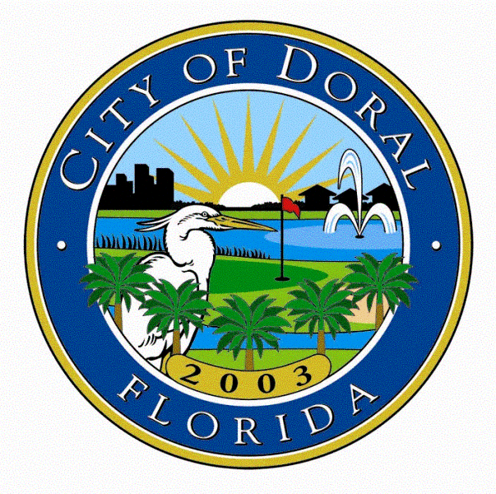
Memorandum

Date: March 12, 2025

To: Honorable Mayor and Councilmembers

From: Zeida Sardinas
City Manager

Department: Erin Sullivan
Parks & Recreation Director

Subject: Approval for the creation and installation of art on the Doral Central Park water tank

Introduction

The City of Doral Parks and Recreation Department respectfully requests the Mayor and City Councilmembers approve the for the creation and installation of art on the Doral Central Park water tank by Jonathan Ramirez in an amount not to exceed $60,000 with a 10% contingency for a total of $66,000. Additionally, the department seeks authorization for the City Manager to negotiate and enter into an agreement with the artist.

Background

On September 9, 2024, the City issued a Call to Artists for the design and installation of art on the Doral Central Park water tank, which was previously approved by Council on August 14, 2024, Resolution No. 24-196. The selected artist(s) will develop a site-specific project with an original and imaginative perspective, transforming the water tank into a captivating artistic focal point for the community. The artwork will incorporate elements of Doral, providing residents and visitors with a visually engaging experience while enhancing the sense of place as they enter Doral Central Park.

The Call to Artists was advertised on the City’s website, social media platforms, email blasts to the City’s database, and the Greater Miami Conventions & Visitors Bureau website. The call closed on October 4, 2024, and a total of twenty (20) proposals from the following artists and groups: Sydia Reyes, EDOMIX, RACCTUS DESIGNZ, Spray & Strokes, Samara Ash, The Stroke Studio, Kelly Perez, Juan Carlos Quijano, Jonathan Ramirez, Boa Mistura, Artist Envision Collective + MIFA, Sergio Arce, Rafael Rangel, Rigo Leon, Jhoselyn Art, Jose Rodriguez, Project Roadmap, XTO Art Studio, Miami Murals, and VCruz.

An Evaluation Panel, consisting of individuals who have served on City advisory boards and/or worked with the City on art and culture initiatives, and who have expertise in the field, met on December 4, 2024, in a publicly noticed meeting, for a Phase I evaluation. During this meeting, the panel reviewed the submissions and shortlisted ten (10) proposals for final evaluation. The ten (10) shortlisted for phase II were EDOMIX, RACCTUS DESIGNZ, Spray & Strokes, Samara Ash, The Stroke Studio, Kelly Perez, Jonathan Ramirez, Boa Mistura, Project Roadmap, and Miami Murals. Nine (9) proposals were disqualified for failing to comply with the budget limits or for failing to include a detailed budget, and one (1) artist, Rigo Leon, withdrew their proposal. The panel also requested revisions and clarifications for the shortlisted proposals at the phase I evaluation.

On January 24, 2025, the Evaluation Panel reconvened (Phase II) in a publicly noticed meeting to conduct final evaluations. The Evaluation Panel shortlisted the following five (5) top-ranked proposals as follows:

1. Boa Mistura
2. Samara Ash
3. Project Roadmap
4. EDOMIX
5. Jonathan Ramirez

Staff also reviewed the top five (5) proposals shortlisted by the evaluation committee. After review, staff recommend Jonathan Ramirez’s proposal as the top ranked submission. Mr. Ramirez is a Doral Resident and it’s important to provide local artists especially, Doral a resident the opportunity to create art for his own City. Additionally, since he is a resident, he understands the community and what makes Doral special, which is shown in his artwork. His submission depicted elements of Doral Central Park and other iconic landmarks in Doral. He also is excited to engage the community with the project and detailed numerous ways for the community to paint and participate in creating the mural, which is an important component.

Fiscal Impact

This item has an estimated fiscal impact of $60,000.00 with a 10% contingency totaling $66,000. This amount does not exceed budgeted funds in account 110.90005.500652 (Public Art Fund – capital outlay-other)

Strategic Plan Alignment

This item ties into the Parks & Recreation and Cultural Programming Strategic Plan Initiatives, as this public art installation contributes to enhancing the visual appeal of the city's infrastructure and enriching the cultural experience of our community.

Recommendation

The City Manager’s Office respectfully requests approval from the Mayor and City Councilmembers to approve the creation and installation of art on the Doral Central Park water tank by Jonathan Ramirez in an amount not to exceed $60,000 with a 10% contingency for a total of $66,000 and authorize the City Manager to enter into an agreement with the selected artist.
Additionally, staff respectfully requests to authorize the City Manager’s Office to work with the selected artist to finalize the mural design.

This item has an estimated fiscal impact of $60,000.00. This amount does not exceed budgeted funds in account 110.90005.500652 (Public Art Fund – capital outlay-other)

Attachments:
- Jonathan Ramirez- Two (2) rendering options for review
- Seven (7) shortlisted by the Evaluation Panel during Phase I meeting:
- DCP Water Tank Proposal from EDOMIX
- DCP Water Tank Proposal from RACCTUS DESIGNZ
- DCP Water Tank Proposal from Spray & Strokes
- DCP Water Tank Proposal from Samara Ash
- DCP Water Tank Proposal from The Stroke Studio
- DCP Water Tank Proposal from Kelly Perez
- DCP Water Tank Proposal from Jonathan Ramirez
- DCP Water Tank Proposal from Boa Mistura
- DCP Water Tank Proposal from Miami Murals
- DCP Water Tank Proposal from Project Roadmap
- (10) additional proposals received and disqualified during Phase I meeting:
- DCP Water Tank Proposal from Sydia Reyes
- DCP Water Tank Proposal from Juan Carlos Quijano
- DCP Water Tank Proposal from Artist Envision Collective + MIFA
- DCP Water Tank Proposal from Sergio Arce
- DCP Water Tank Proposal from Rafael Rangel
- DCP Water Tank Proposal from Rigo Leon
- DCP Water Tank Proposal from Jhoselyn Art
- DCP Water Tank Proposal from Jose Rodriguez
- DCP Water Tank Proposal from XTO Art Studio
- DCP Water Tank Proposal from VCruz

